**Seminar #2 Report**

NIE YONGXIN 2186113564

### Part 1:

# Topic

Three-Phase Full Bridge Rectifier (thyristor version)

# Simulation Model

There are two models established to simulate three-phase full bridge rectifier (thyristor version)

## *2.1 (Simulation model 1)*

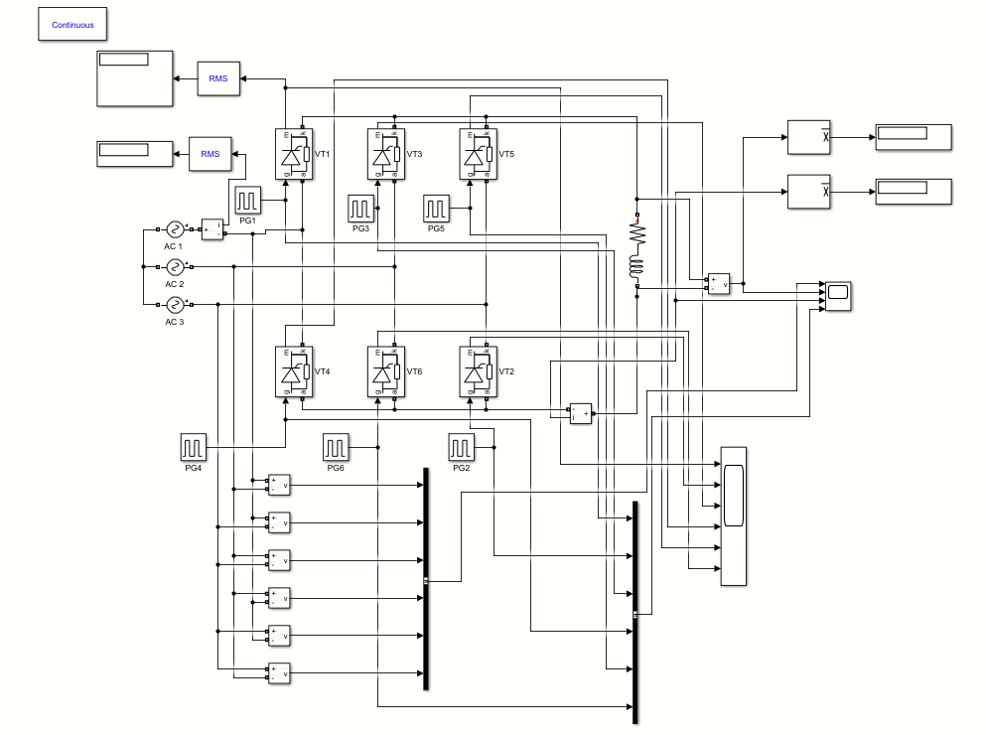

Figure 1: Simulation model 1

This model is established to simulate three-phase full bridge rectifier (thyristor version) under rectification mode. It includes three AC sources, six thyristors with six pulse generators correspondingly, and an inductive load. In order to observe the waveforms of Ud, Id, phase to phase voltage, pulse voltage and current of thyristor, there are also some voltage measurements, current measurements, bus creators and scopes. And we also use some RMS blocks, mean blocks and displayers to display simulation results .

## *2.2 (model 2)*

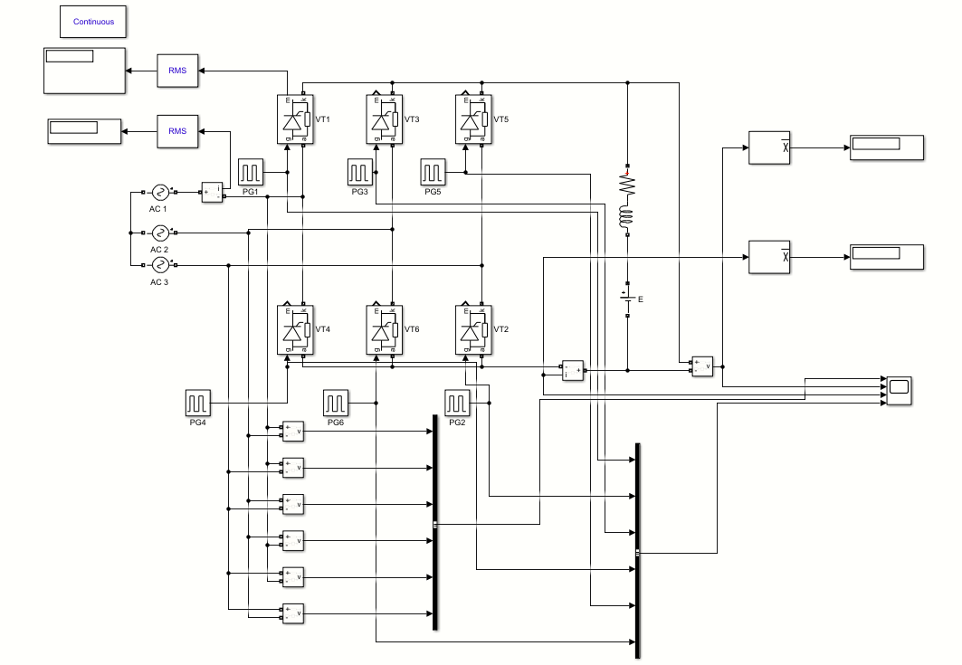

Figure 2: Simulation model 2

This model is established to simulate three-phase full bridge rectifier (thyristor version) under active inversion mode. It includes three AC sources, six thyristors with six pulse generators correspondingly, an inductive load and a back EMF. In order to observe the waveforms of Ud, Id, phase to phase voltage and pulse voltage, there are also some voltage measurements, current measurements, bus creators and scopes. And we also use some RMS blocks, mean blocks and displayers to display simulation results .

# Parameter Setup

*3.1 (AC source parameters)*

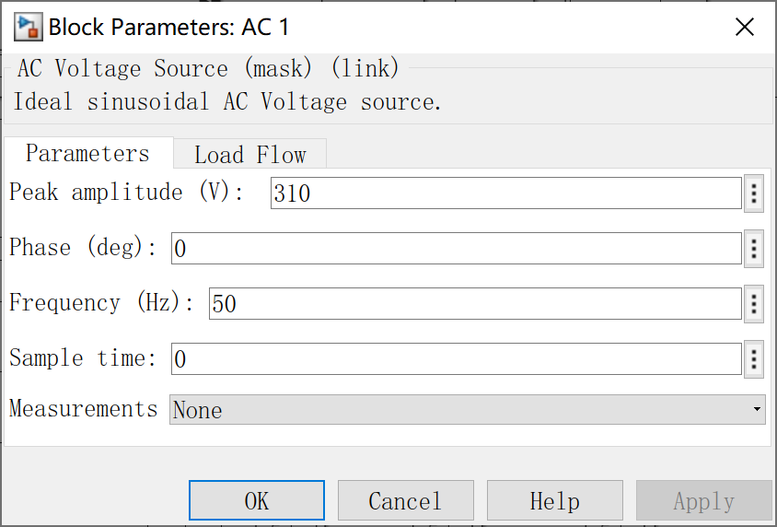 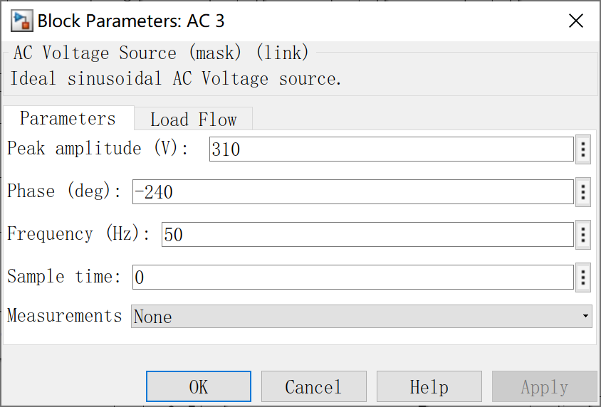

Figure 3: AC1 source parameters

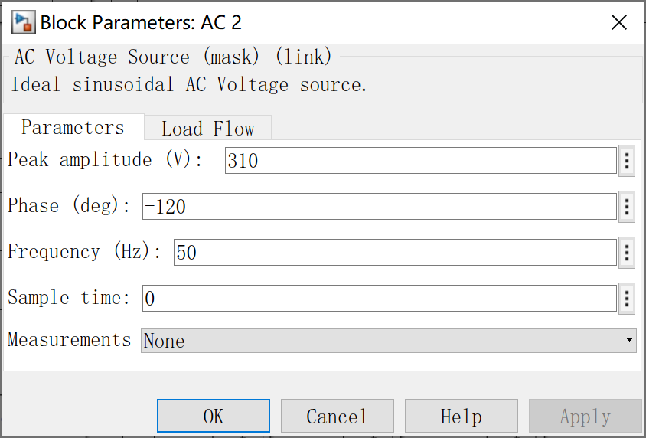

Figure 4: AC1 source parameters

*3.1(Pulse trigger time calculation)*

|  |  |
| --- | --- |
| **Matlab code** | **result** |
| a=85;  f=50;  T=1/f;  VT1=(a+30)/360*T  VT2=(a+30+60)/360*T  VT3=(a+30+120)/360*T  VT4=(a+30+180)/360*T  VT5=(a+30+240)/360*T  VT6=(a+30+300)/360*T | VT1 =0.0064  VT2 =0.0097  VT3 =0.0131  VT4 =0.0164  VT5 =0.0197  VT6 =0.0231 |
| a=170;  f=50;  T=1/f;  VT1=(a+30)/360*T  VT2=(a+30+60)/360*T  VT3=(a+30+120)/360*T  VT4=(a+30+180)/360*T  VT5=(a+30+240)/360*T  VT6=(a+30+300)/360*T | VT1 =0.0111  VT2 =0.0144  VT3 =0.0178  VT4 =0.0211  VT5 =0.0244  VT6 =0.0278 |

*3.1 (Pulse parameters setup)*

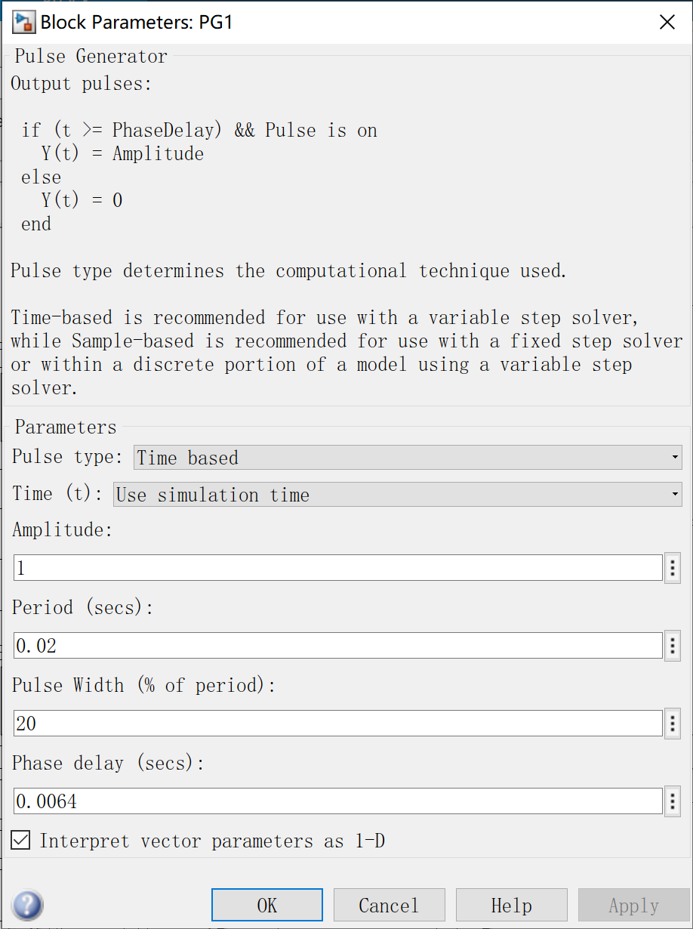 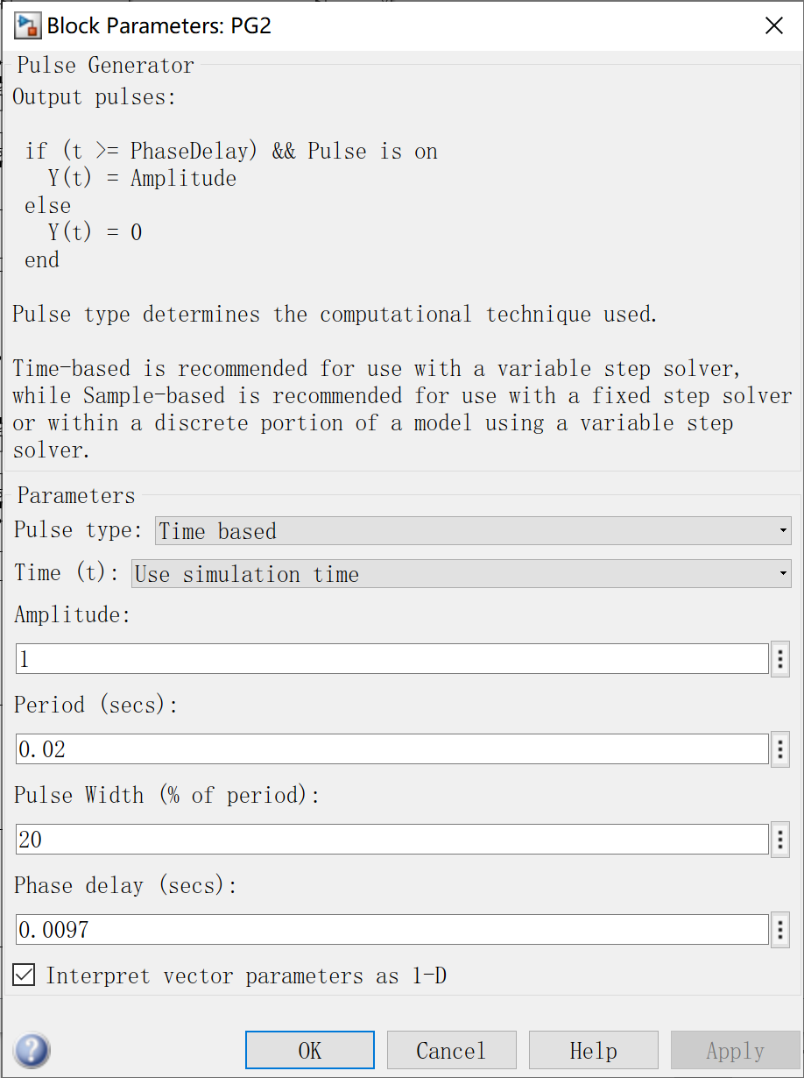 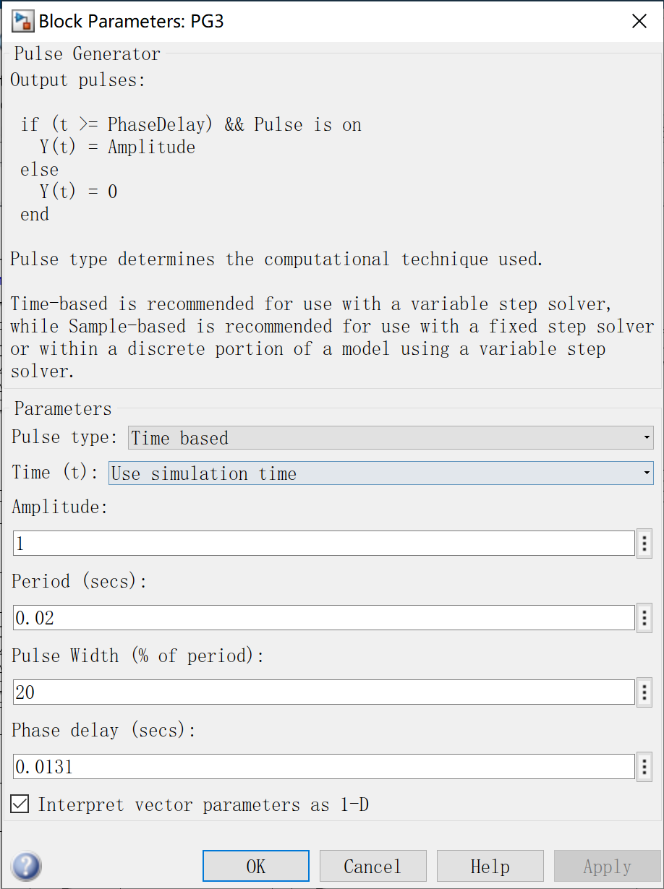

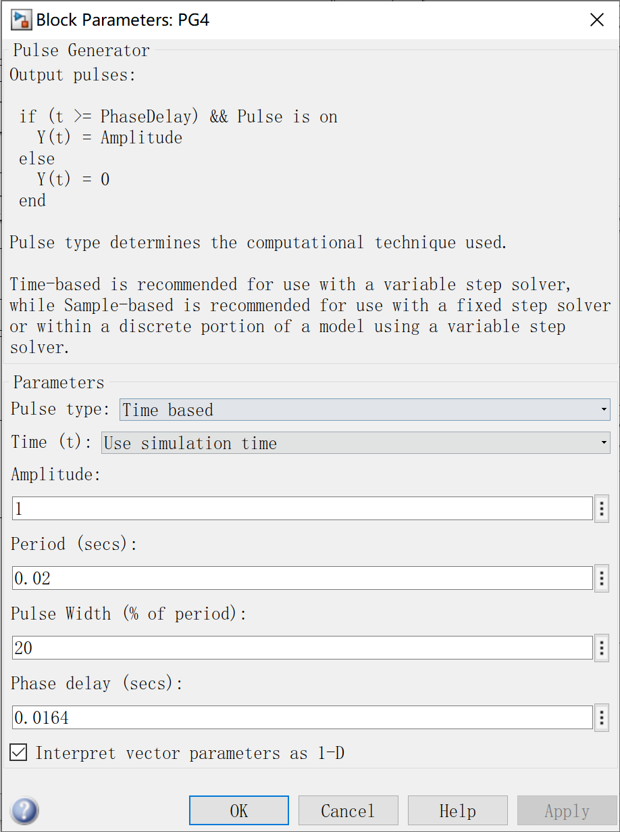 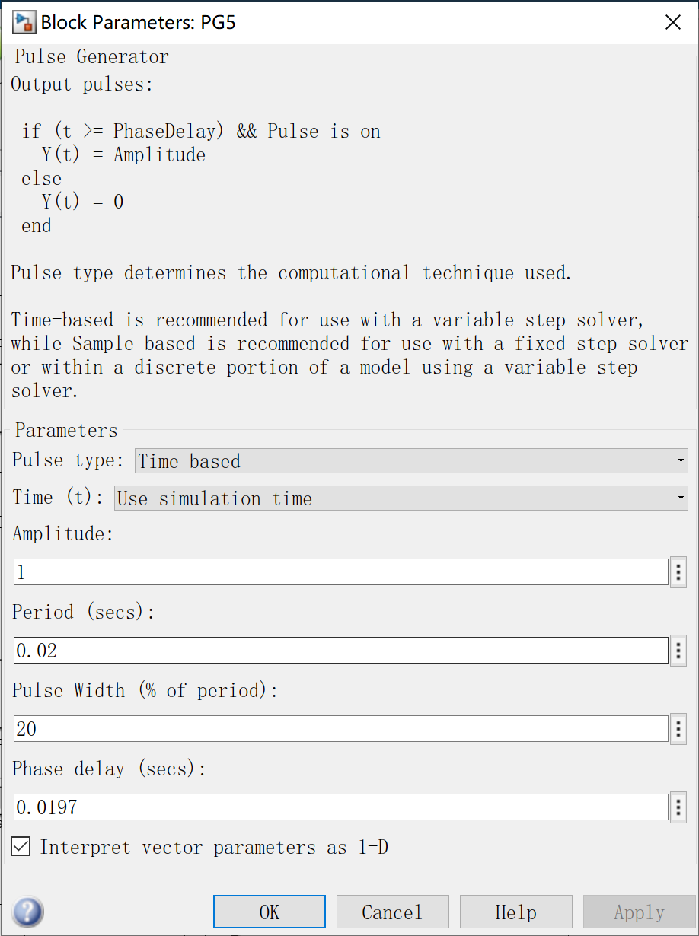 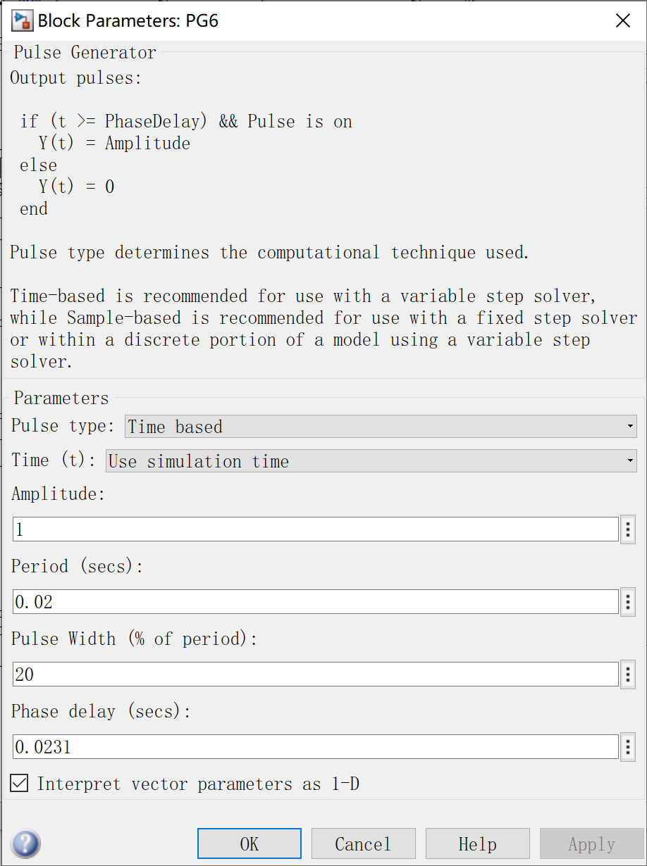

Figure 5: pulse generator parameters of part 1 model 1

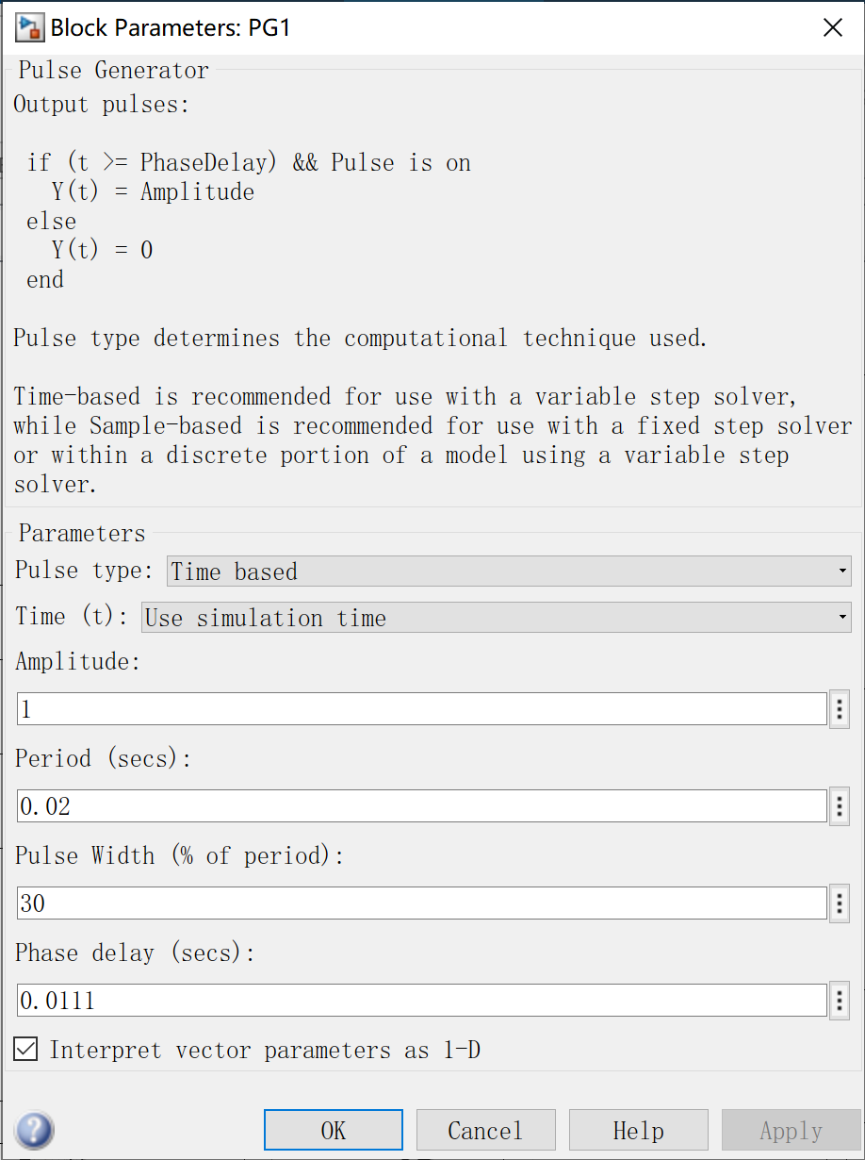 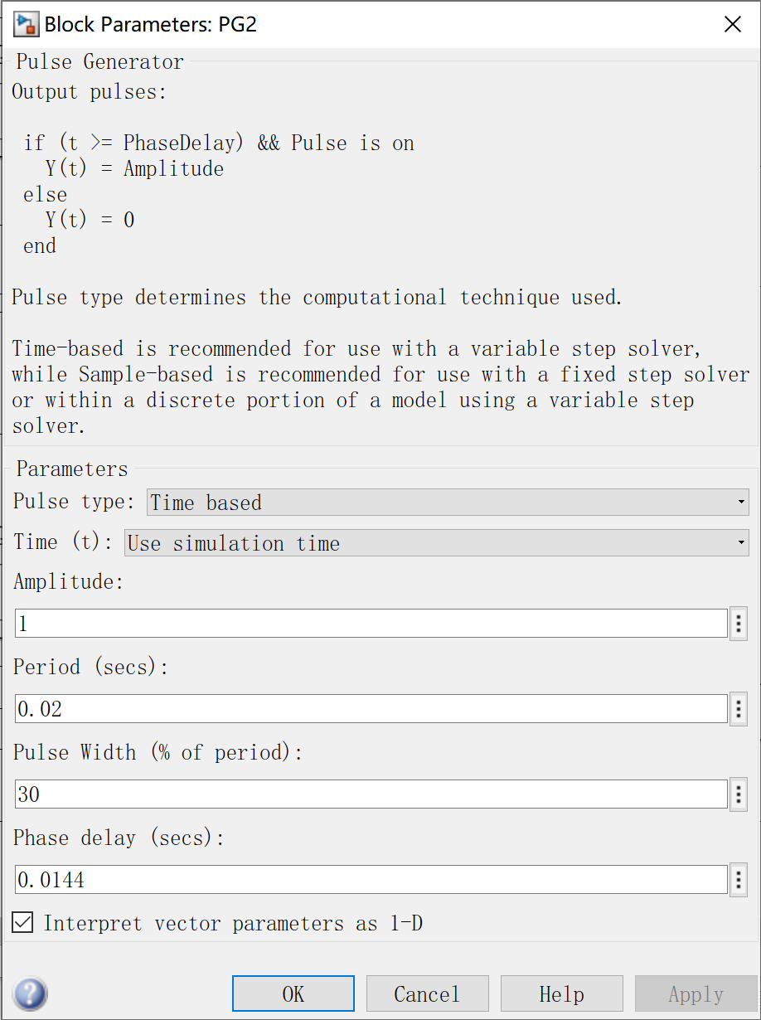 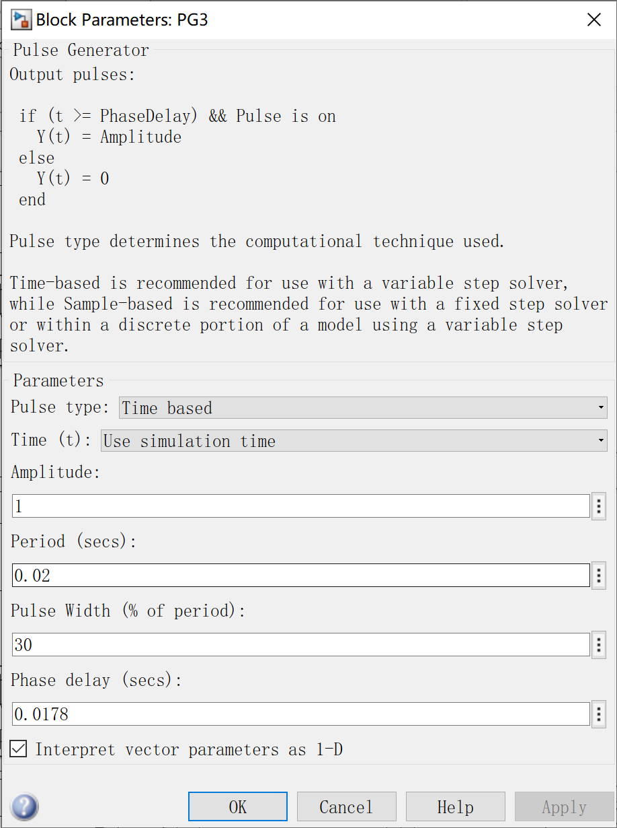

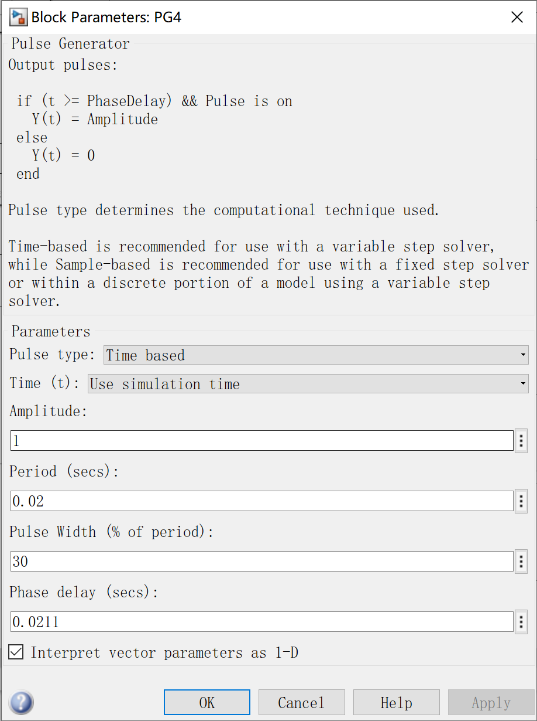 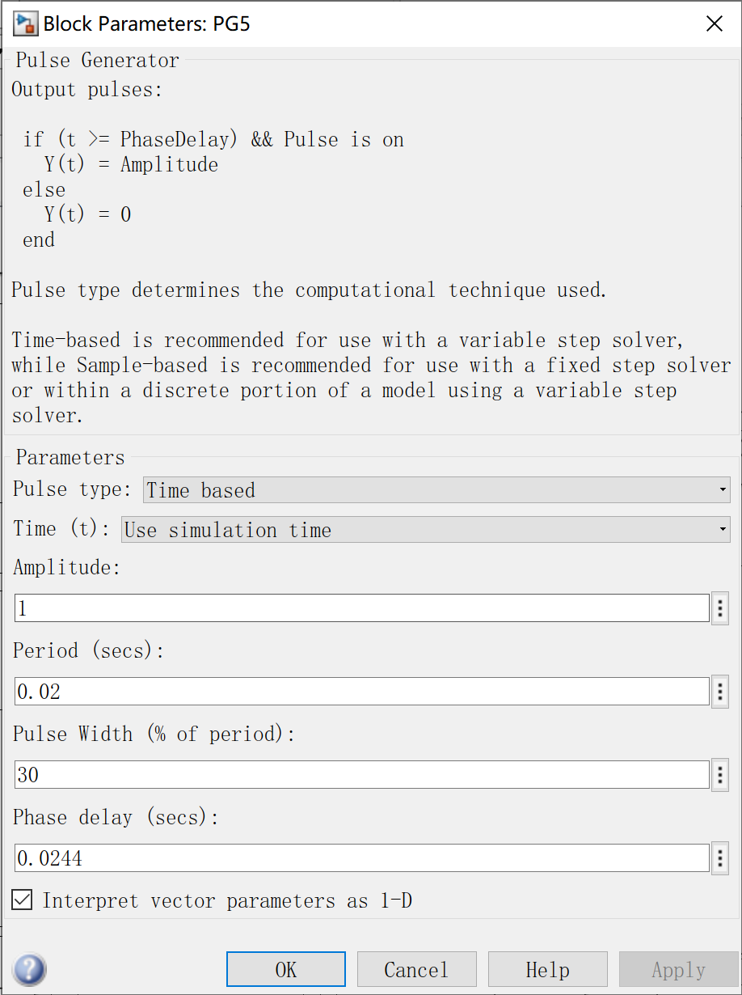 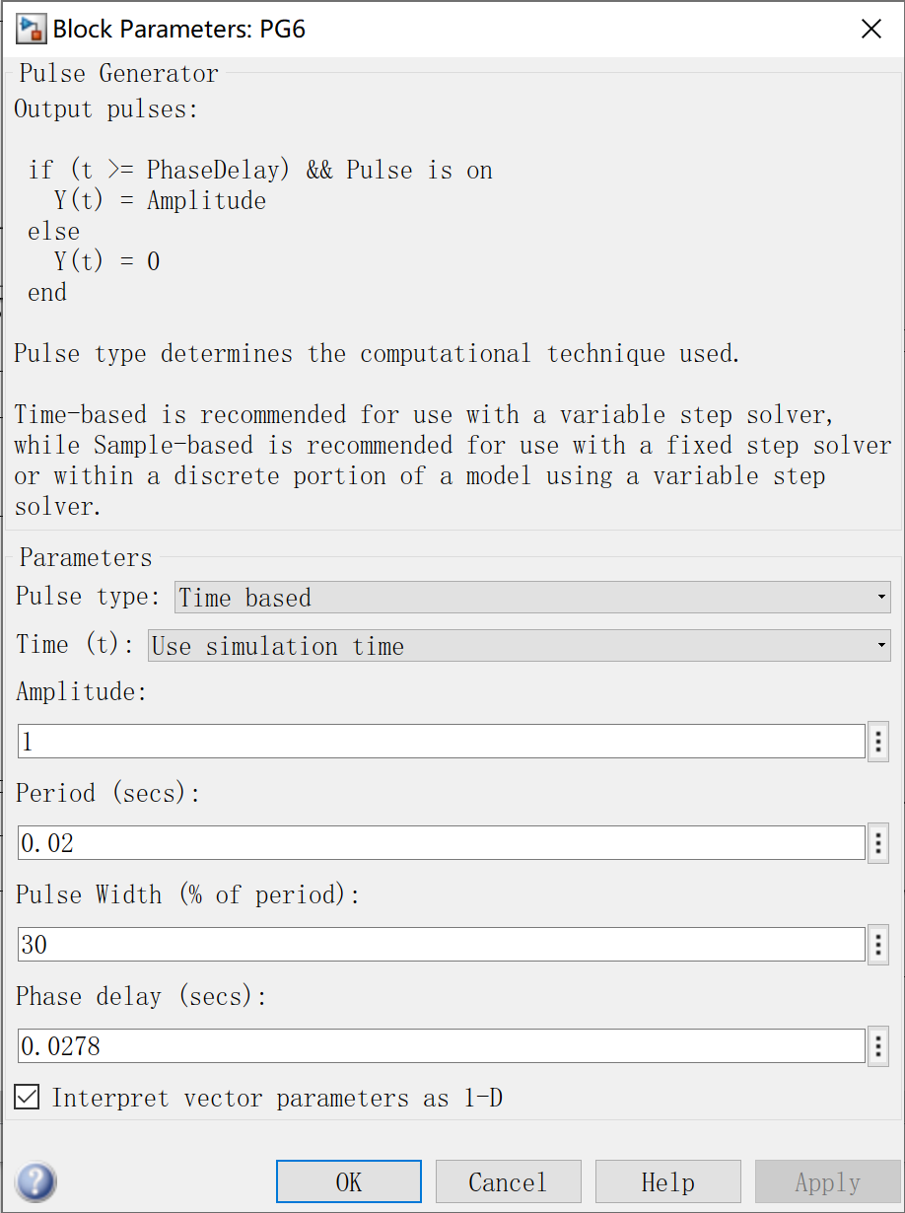

Figure 5: pulse generator parameters of part 1 model 2

*3.3(other parameters*

|  |  |  |  |  |
| --- | --- | --- | --- | --- |
| ***L*** | ***R*** | ***E*** | ***α1*** | ***α2*** |
| 5mH | 1Ω | -400V | 85° | 170° |

# Simulation Results

*3.1 (Result of model 1)*

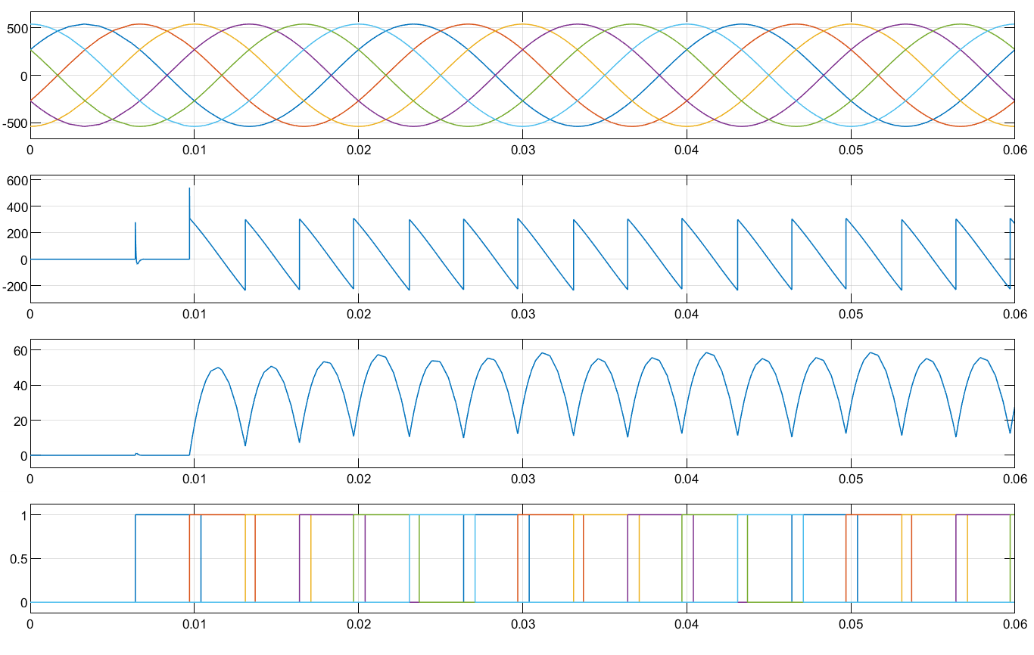

Figure 5: waveforms of phase to phase voltage, Ud, Id, and pulse voltage (**α1=**85°)

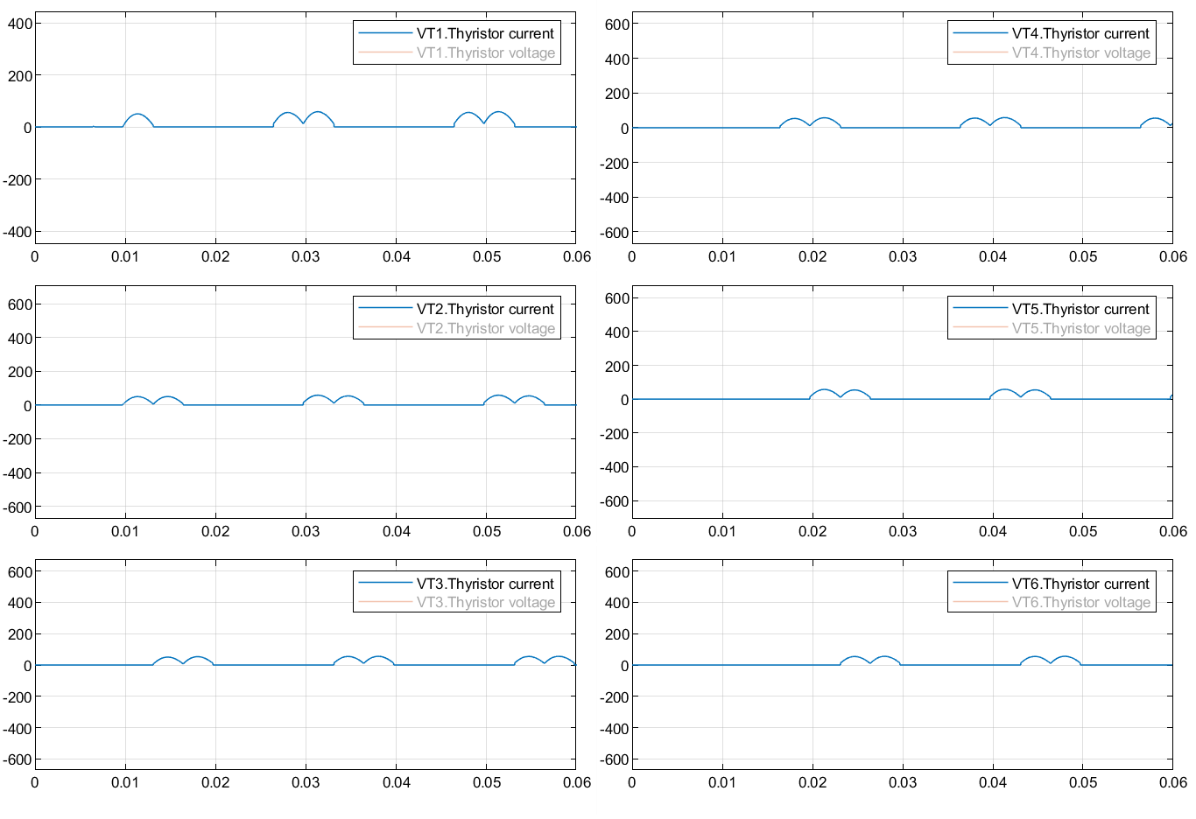

Figure 6: waveforms of current of thyristor

The sequence of driving signal of each thyristor is VT1 - VT2 - VT3 - VT4 - VT5 - VT6.

*3.1 (Result of model 2)*

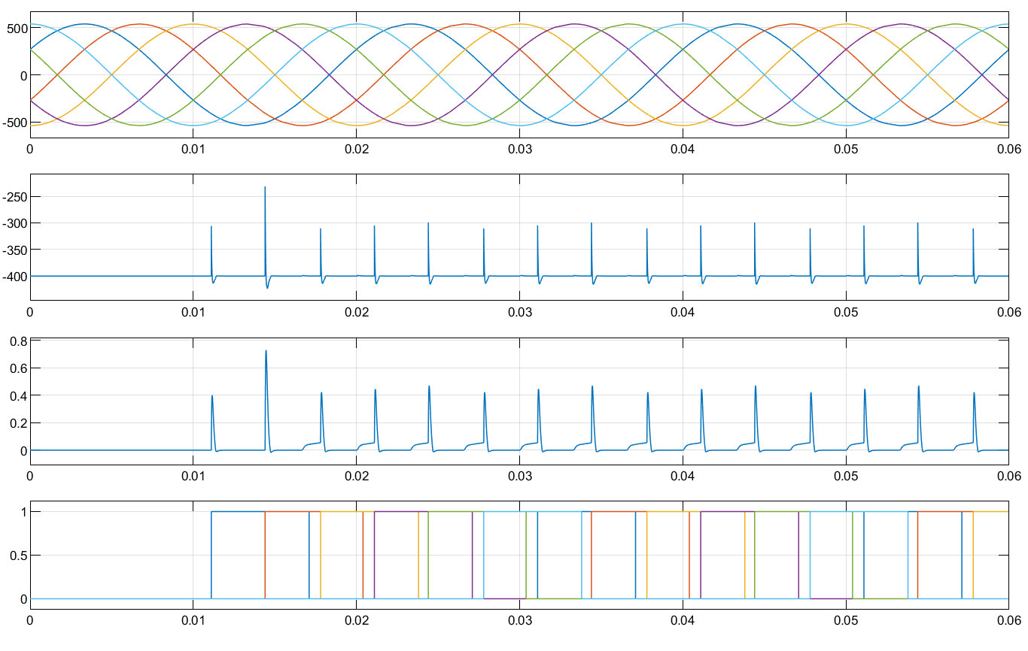

Figure 7: waveforms of phase to phase voltage, Ud, Id, and pulse voltage with back EMF (**α2=170°**)

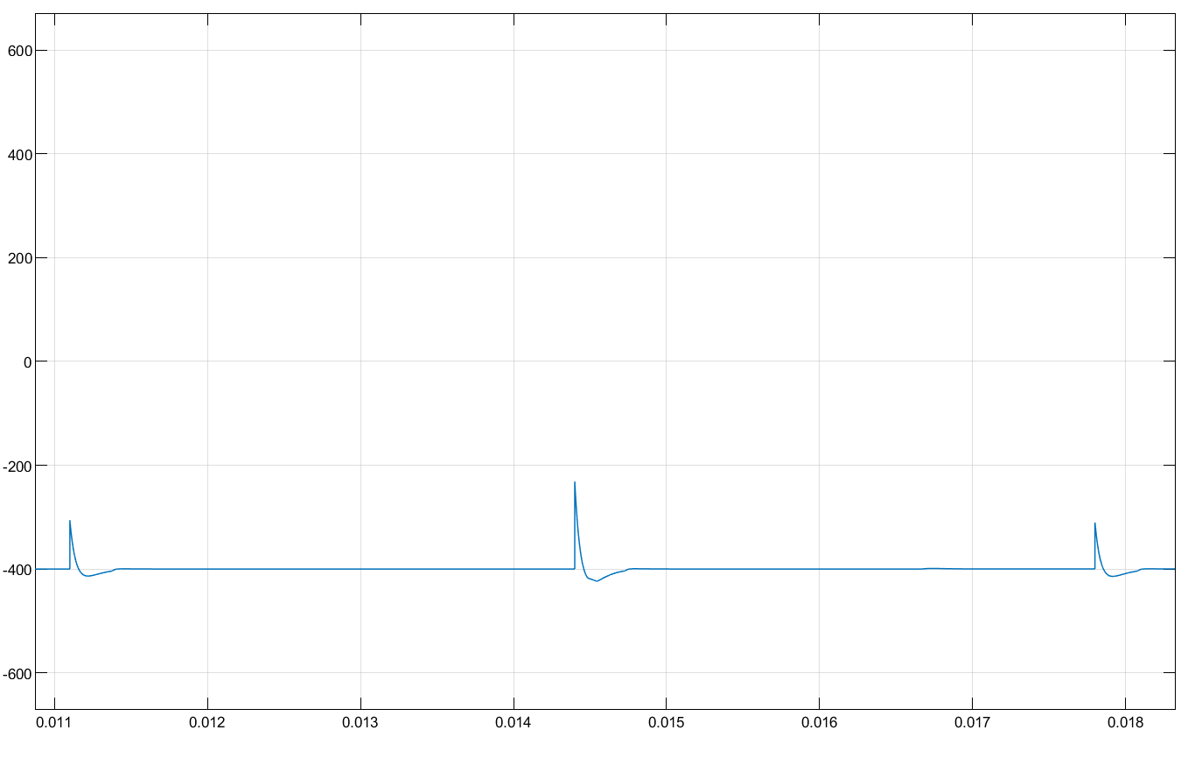

Figure 8: waveform of Ud

# Analysis of the Results

*3.1 (theoretical calculation of model 1)*

|  |  |
| --- | --- |
| theoretical calculations of rectification mode | theoretical calculations of inversion mode |
|  |  |

*3.1 (result of model 1)*

|  |  |  |  |  |  |  |
| --- | --- | --- | --- | --- | --- | --- |
|  | Rectification Mode | | | Active Inversion Mode | | |
| theoretical results | simulation results | error | theoretical results | simulation results | error |
| *Ud* | 44.87V | 42.31V | 5.71% | -506.98V | -400V |  |
| *Id* | 44.87A | 40.87A | 8.91% | -106.98A | 0.03187A |  |
| *I2* | 36.64A | 33.92A | 7.42% | -87.39A | 0.07383A |  |
| *IVT* | 25.91A | 28.46A | 9.84% | -61.76A | 0.07439A |  |

*3.1 (analysis of part 1)*

According to the data in the table, we find the simulation statistics of rectification mode is similar to the theoretical results. However, the simulation statistics of active inversion mode is quite different from the theoretical results. Therefore, we did some further research to look up into this question.

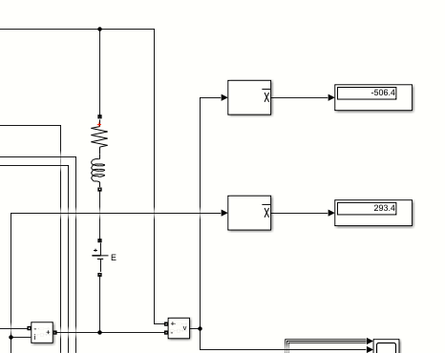

Figure 9: simulation results of Ud and Id

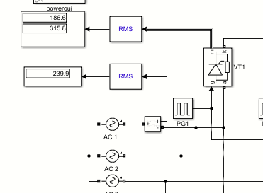

Figure 10: simulation results of IVT and I2

We find that the absolute value of *E* is less than the absolute value of *Ud* when calculated according to the given data, and the calculated current is negative. From the conduction characteristics of thyristor, it is impossible to happen in practice. When we change *E* to -800V, the simulation results are in good agreement with the theoretical value. This is because when the absolute value of E is less than the absolute value of *UD*, *E* is not enough to send electric energy from DC side to AC side.

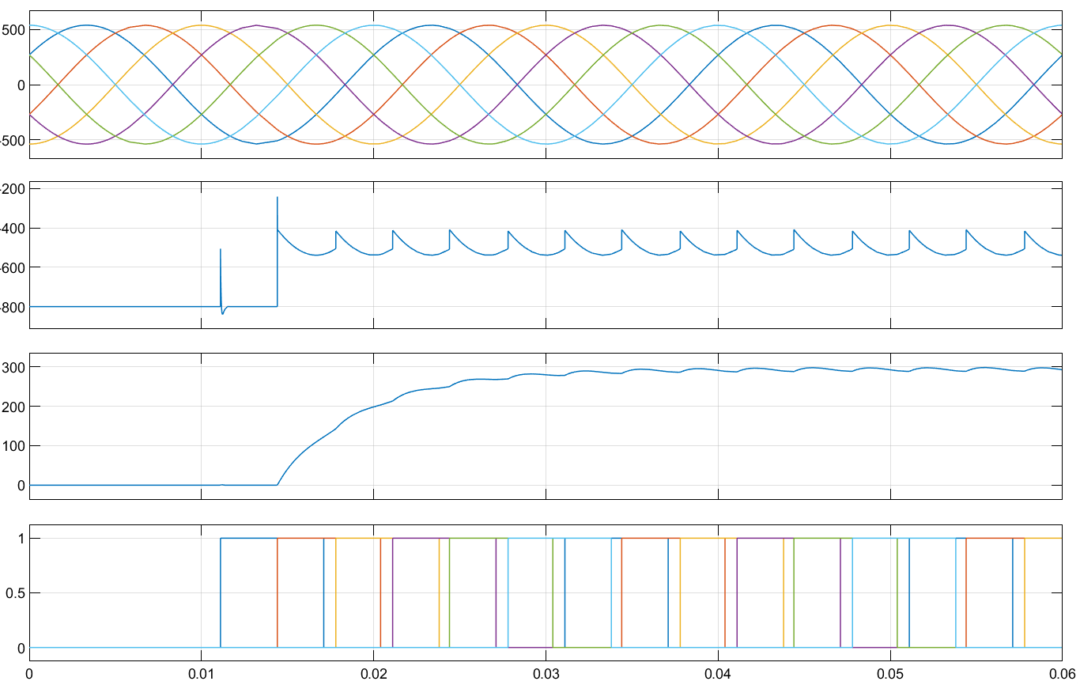

Figure 10: waveforms of phase to phase voltage, Ud, Id, and pulse voltage with back EMF (E=-800V)

### Part 2:

# Topic

Three-Phase Full Bridge Rectifier ( power diode version)

# Simulation Model

There is onr model established to simulate three-phase full bridge rectifier ( power diode version)

*2.1 (Simulation model )*

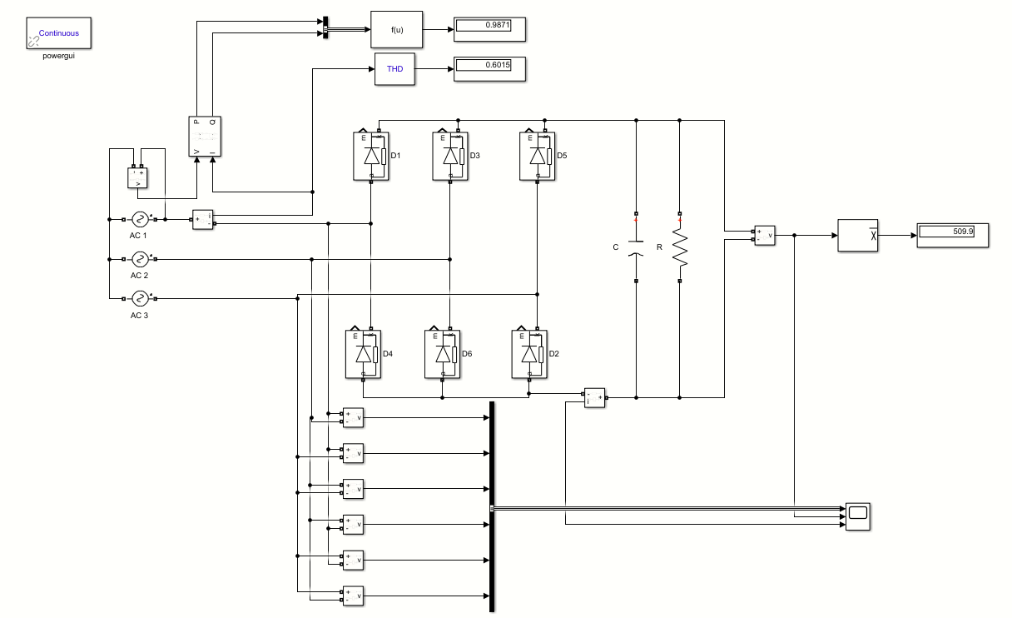

Figure 1: Simulation model 3

This model is established to simulate three-phase full bridge rectifier (power diode version). It includes three AC sources, six power diodes, a resistor and a capacitor. In order to observe the waveforms of Ud, Id, phase to phase voltage, there are also some voltage measurements, current measurements, power measurements, bus creators and scopes. And we also use some RMS blocks, mean blocks, THD blocks, function blocks, and displayers to display simulation results .

# Parameter Setup

*3.1 (AC source parameters)*

 



Figure 2: AC1 source parameters

*3.1 (Other parameters)*

|  |  |
| --- | --- |
| **C** | 5.5mF |

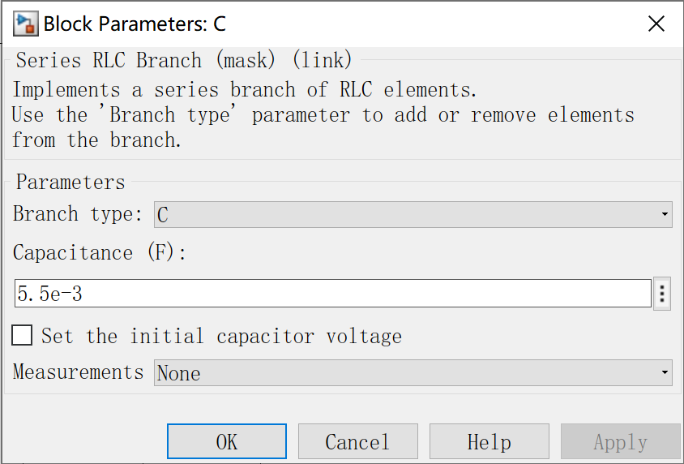

Figure 3: capacitor parameters

# Simulation Results

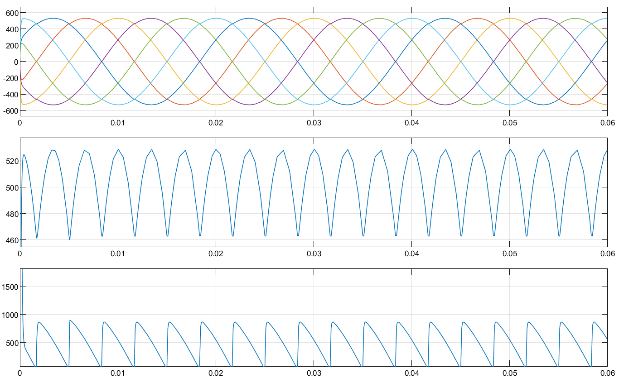

Figure 4: waveforms of phase to phase voltage, Ud and Id

# Analysis of the Results

The results of part2 are:

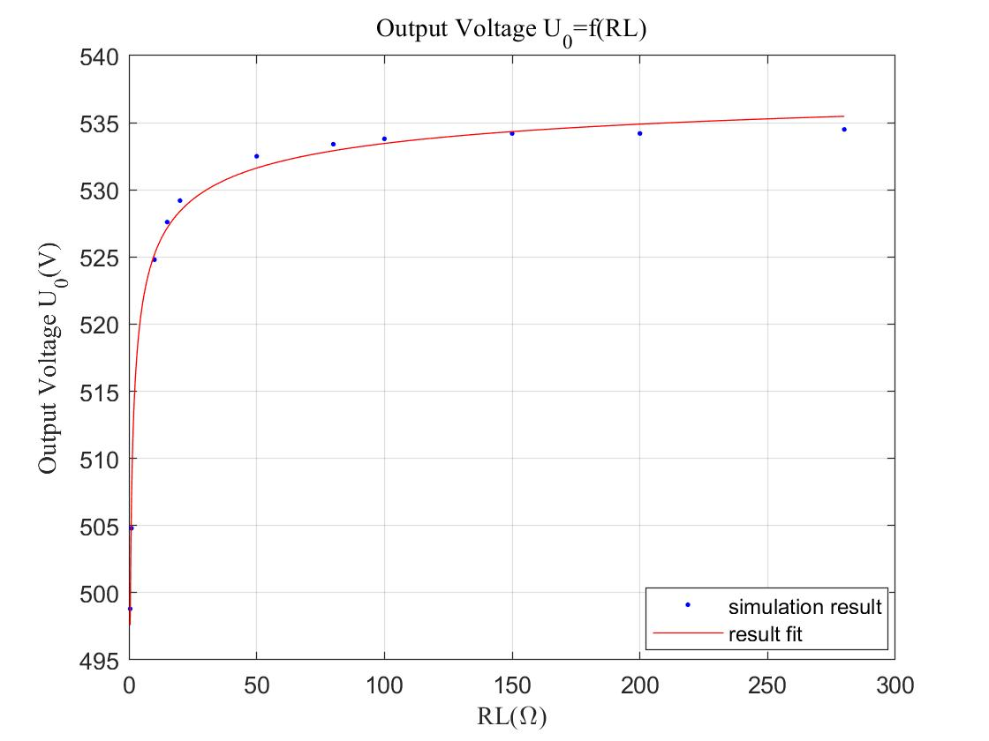

Figure 5 *Uo* = f(RL)

We test 10 points of RL, from 1 ohm to 280 ohm. The result shows that the output voltage increases with the resistance increasing, starting from 550V to around 535V. And when the resistance is about 30 ohm, the increasing rate is getting slow down.

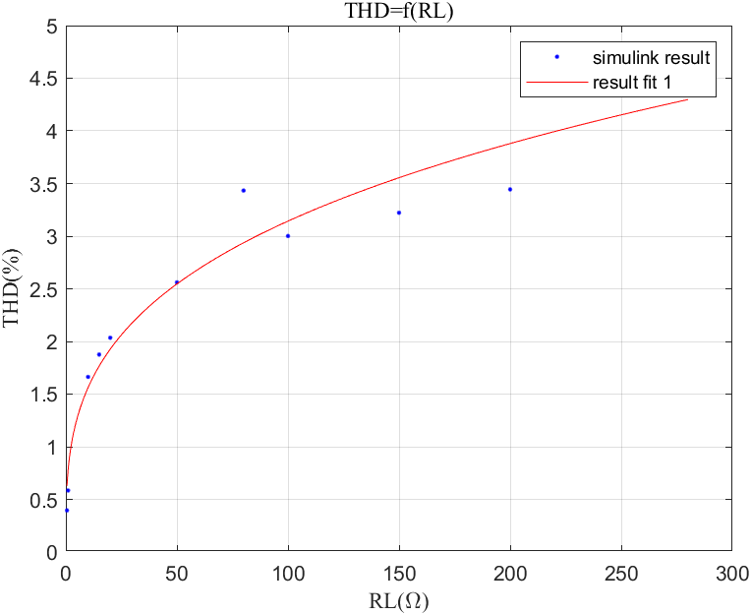

Figure 6 THD = f(RL)

The THD increases with the resistance increasing, starting from 0.5 to around 4.5.

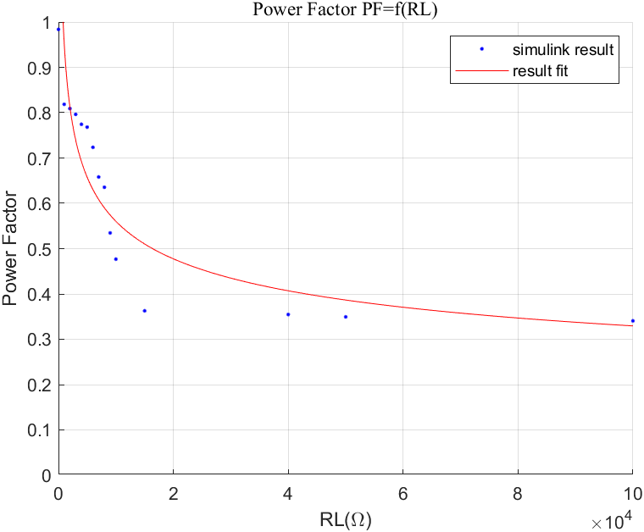

Figure 7 PF = f(RL)

The power factor decreases with the resistance increasing, starting from about 1 to around 0.35. And when the resistance is about 1000 ohm, the increasing rate is getting slow down.

As we know, the critical condition  is the intermittent and continuity of the waveform of current *id*. When the resistance is large, the curve of current id is continuous. Meanwhile, when the load is small, the curve of current id isn’t continuous. The bellowing might be the reason why the inflection point turns out.

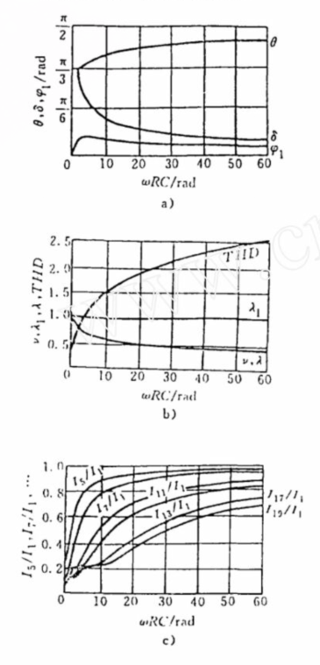

Figure 8 results from literature

This is a figure that we found in a paper about the three-phase full bridge rectifier with capacitor impedance. It is very similar to the results we got in the Simulink.